**TWO STEP BLOCK**

**Requirements:**

Qty 1     4.5" square (print fabric)

Qty 2     2.5" x 4.5" rectangles

Qty 2     2.5" x 8.5" rectangles

Colors: Think gloriously colorful, totally scrappy

**Step 1:**

Sew 2 shorter rectangles together on long side.

Sew rectangle pair to bottom of square.

**Step 2:**

Sew 2 long rectangles together on long side.

Sew rectangle pair to right-hand side of step 1 unit (so that when block is complete, the square will be in the upper left-hand corner).

That’s all there is to it. Block should measure 8.5”.

Please keep the following in mind as you pull your fabrics.

* Try to keep good contrast between all your fabrics.

* Please only use each fabric once per block.

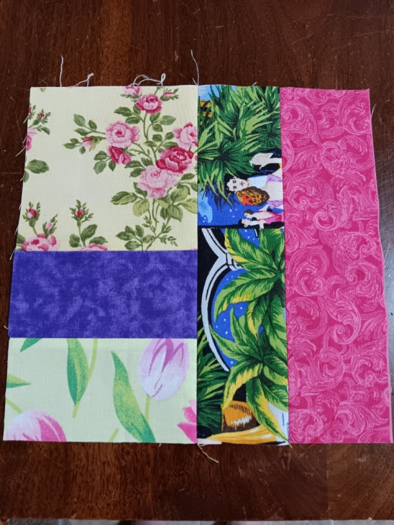

As always, have fun and enjoy the process.

If you have any questions, please feel free to contact me.

Laura Miller

Call/text: 509-710-2953

Email: [scrappyquiltsrme@gmail.com](mailto:scrappyquiltsrme@gmail.com)